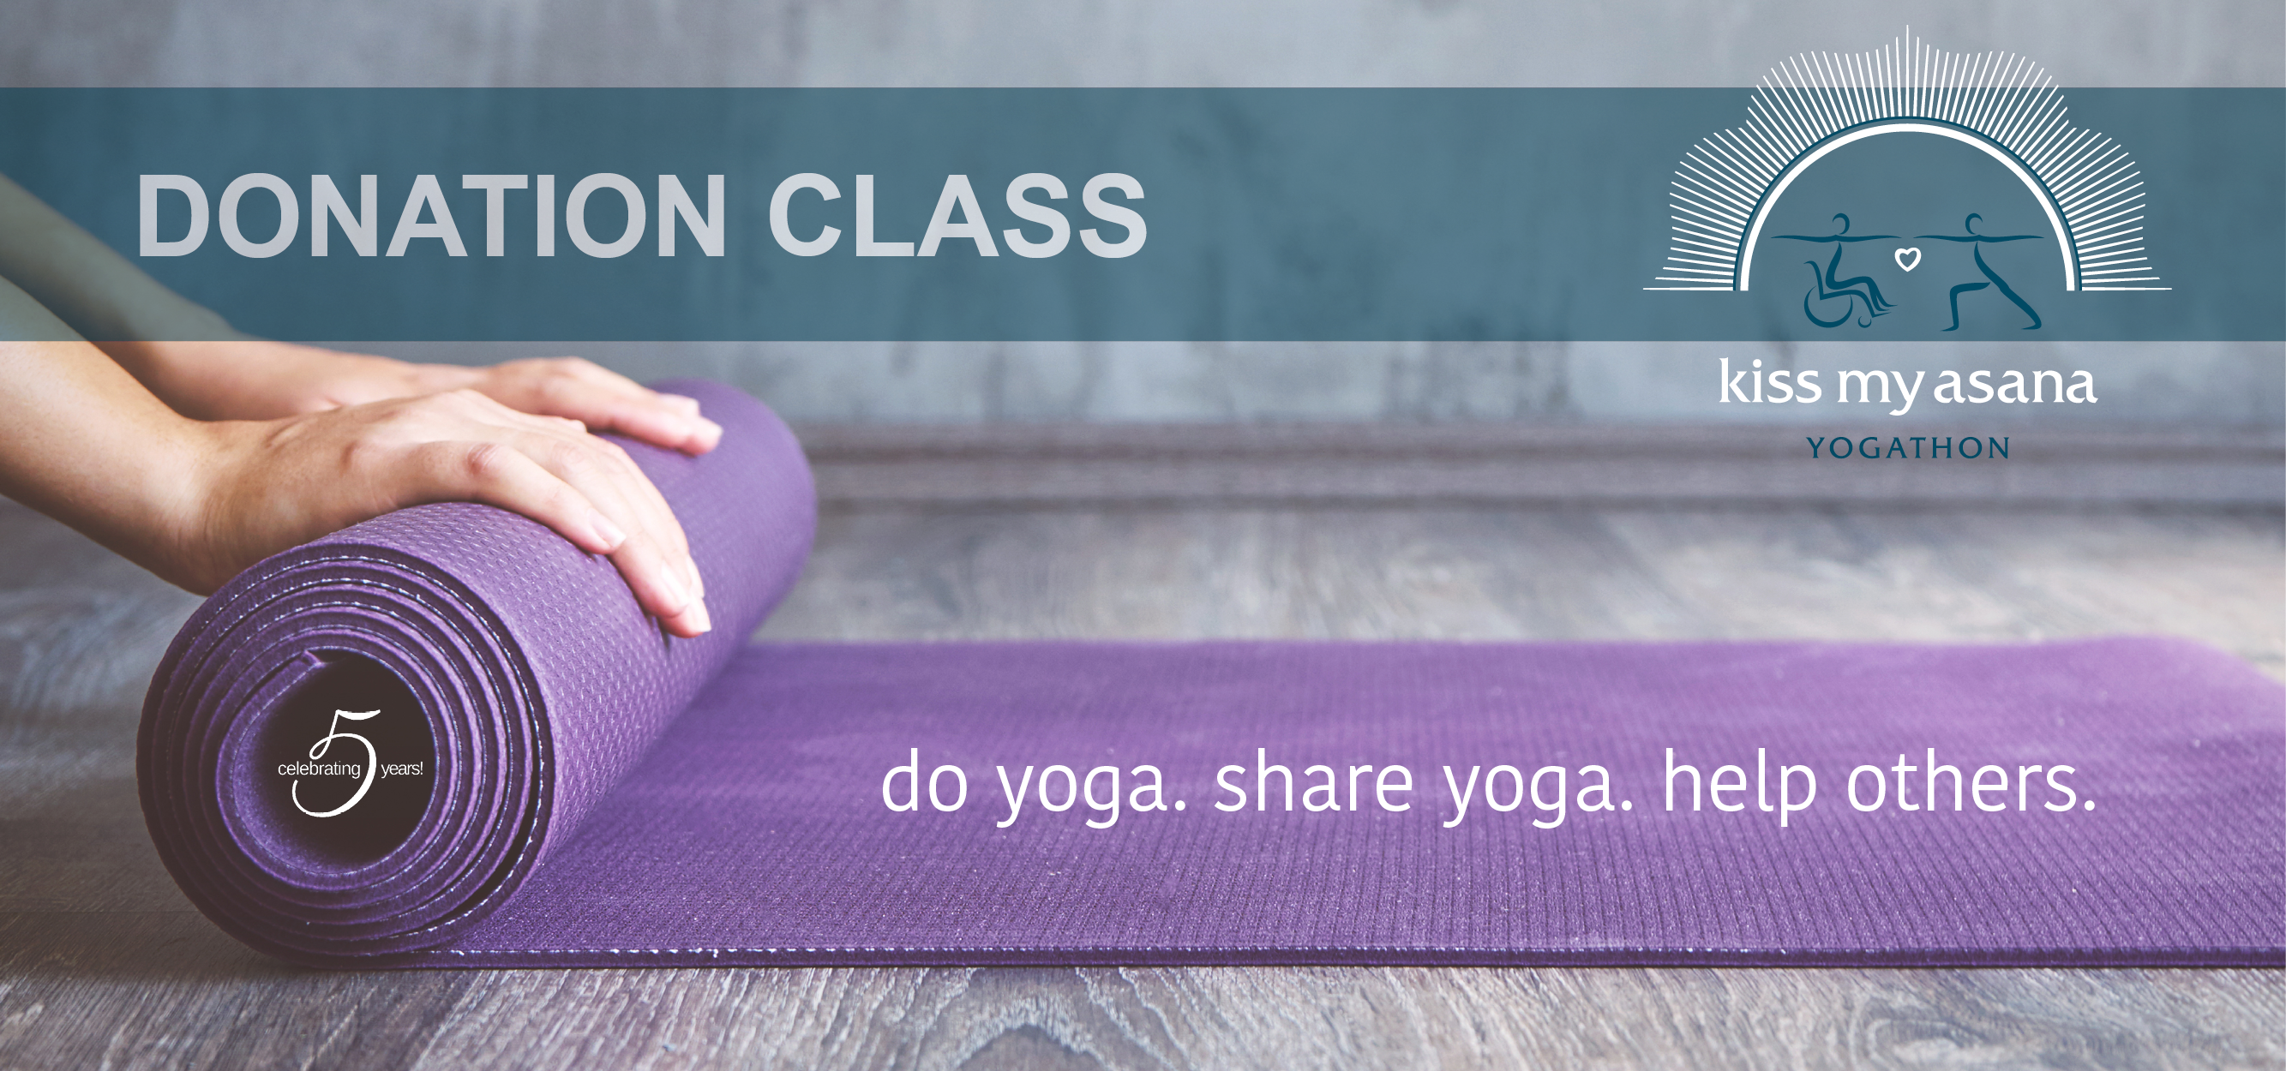

Insert Studio Logo Here

**Join us and support our friends at Mind Body Solutions!**

**This all levels class benefits the adaptive yoga program at MBS,**

**a non-profit founded by Matthew Sanford with a mission to serve**

**people living with trauma, loss, and disability.**

**[Type in the Date & Time Here]**

Taught by  
**Type in Teacher’s Name**

MBS transforms lives of people living all over the world by opening yoga to everybody.

Through their work, and the teachers they train to teach adaptive yoga, MBS shares the gift of yoga with US MILITARY VETS, PEOPLE WITH DISABILTIY, SURVIVORS OF SEXUAL ASSAULT,

THE ELDERLY AND PEOPLE LIVING WITH CHRONIC PAIN.

**$20 Suggested Minimum Donation**

[Name of Venue / Address]

**Sign up today: [website.com/register] or [230.987.9876]**